**Computer network – jerico 2101664763**

1 A. default subnet mask : 255.255.255.0

B. network address : 192.168.100.0

C. broadcast address : 192.168.100.255

D. jumlah device dalam 1 network : 254

2. A. untuk membagi menjadi 32 network, menjadi /29

Subnet mask terbaru : 255.255.255.248

B. 192.168.100.0 – 192.168.100.7, yang bisa dipakai 1 – 6, berarti jumlah device per jaringan = 6

( 256 : 32 = 8 – 2 = 6 )

C. I.

Network Address PC A 192.168.100.8

Network Address PC B 192.168.100.16

Network Address PC C 192.168.100.40

Network Address PC D 192.168.100.56

Network Address PC E 192.168.100.64

Network Address PC F 192.168.100.80

Network Address PC G 192.168.100.220

Network Address PC H 192.168.100.248

Network Address PC J 192.168.100.248

II.

Broadcast Address PC A 192.168.100.15

Broadcast Address PC B 192.168.100.23

Broadcast Address PC C 192.168.100.47

Broadcast Address PC D 192.168.100. 63

Broadcast Address PC E 192.168.100.71

Broadcast Address PC F 192.168.100.87

Broadcast Address PC G 192.168.100.231

Broadcast Address PC H 192.168.100.255

Broadcast Address PC J 192.168.100.255

III.

Gateaway PC A 192.168.100.9

Gateaway PC B 192.168.100.17

Gateaway PC C 192.168.100.41

Gateaway PC D 192.168.100.57

Gateaway PC E 192.168.100.65

Gateaway PC F 192.168.100.81

Gateaway PC G 192.168.100.225

Gateaway PC H 192.168.100.249

Gateaway PC J 192.168.100.249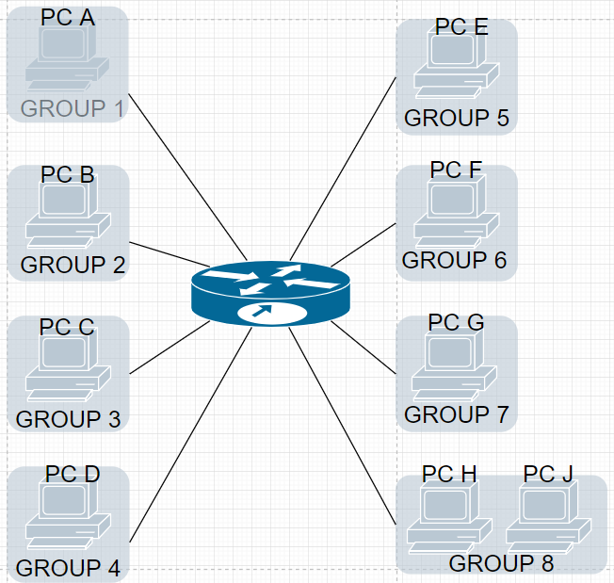

D.